

**Comp 442-Software Engineering**

**Internship Guide**

**Omar Omar 202102211**

**Zaher Ismail 202205114**

**Omar Majzoub 202303428**

**Khalil Aidibi 202303982**

**Tamara Salloum 2023002595**

**Supervised By Dr. Imane Haidar**

**Spring 2024/2025**

Contents

Project description 4

Project overview: 4

Project Objectives: 4

Background: 5

Literature Review: 5

Applications: 6

Alternative Design: 7

Project Planning 7

Project constraint 7

Project issues 9

Team Members and Tasks 9

Ethical Issues 10

Software Model Process 10

Feasibility Study 11

Tools/Technology 11

Standards 11

Milestones 12

Requirements 13

Use Cases 13

Functional Requirements 14

Data Requirements 14

Non-Functional Requirements 15

Performance Requirements 15

Dependability Requirements 15

Maintainability and Supportability Requirements 15

Security Requirements 16

Usability and Humanity Requirements 16

Look and Feel Requirements 16

Operation and Environmental Requirements 16

Cultural and Political Requirements 16

Legal Requirements 17

Project Design 17

CLASS DIAGRAM 17

Dynamic Model 20

Subsystem Decomposition 24

Hardware / Software Mapping 25

User Interface 25

# Project description

## Project overview:

Our project seeks to make the training setup procedure easier for students and companies by guiding them in selecting and creating efficient training programs in accordance with learning goals. The platform will obtain critical company information, such as pricing structures and duration of the program, to offer clear and pertinent choices.

Designed and developed using HTML, CSS, and MySQL, the website comprises nine primary pages:

* Home Page – States the purpose and capabilities of the platform.
* Recruiter Signup/Login – enables training organizations to set up and advertise vacancies.
* Student Signup/Login – Allows students to surf and apply for courses.
* Resume Search – helps swiftly identify the ideal applicant.
* Internship Search – gives students the freedom to find and sort through available training opportunities.
* Contact Us – Providing options for inquiry and support.
* About Us - Explains the platform's purpose and benefits.

Through its intuitive interface, the system provides seamless experience to recruiters and learners, maximizing the training discovery and enrollment process.

# Project Objectives:

1. Make the process of corporate training program setup easier.
2. Aid in the identification and development of training programs that meet learning objectives.
3. Gather in-depth company data, such as whether the training is paid or not.
4. Create a website with HTML, CSS, java script and MySQL to handle data
5. Improve the efficiency of finding relevant training programs and enhance the overall user experience.
6. Provide a user-friendly interface by ensuring effortless navigation across the website for students and recruiters.
7. Set a rating and feedback system to assist the maintenance of training program quality control.
8. Provide real-time alerting for new internship opportunities, application updates, and related activities.
9. Develop a responsive platform that truly performs across all device categories (desktop computers, tablet devices, and mobile phones).

## Background:

The Internship Portal serves as a valuable link between companies looking for emerging talent and students eager to gain real-world experience. In the current competitive job landscape, internships have become a vital step for students to translate their classroom learning into practical applications, hone essential skills, and expand their professional connections. Internships give companies a chance to mentor and assess potential future hires. This platform makes the process smoother for everyone. Businesses can quickly list openings, and students can find internships that fit their goals. Thanks to its simple and intuitive design, the portal makes it easier to match students with valuable, hands-on opportunities that help them learn and grow.

## Literature Review:

Internship platforms play a crucial role in providing students with the opportunity to gain practical experience in their chosen fields. These platforms not only connect students with companies but also help businesses identify and nurture potential future employees. In Lebanon and across the world, many platforms exist to facilitate these connections, ranging from local services to international networks. While these platforms offer various advantages, such as providing access to global internships and promoting professional growth, they also face challenges such as competition, limited availability of positions, and costs for participants. This literature review highlights notable internship portals and their characteristics, along with the advantages and challenges they present.

1. **UNICEF Lebanon Internship Program**  
   Offers eligible students the chance to gain practical experience within UNICEF's operations in Lebanon.
2. **GoAbroad.com**  
   A comprehensive platform connecting students with internship opportunities worldwide, including Lebanon.
3. **GoOverseas.com**  
   Provides reviews and guides for students seeking internships abroad, including Lebanon.
4. **Absolute Internship**  
   Offers international internship programs in various cities worldwide, including options in Lebanon.
5. **The Intern Group**  
   Provides international internship programs in multiple cities, including Lebanon, and offers both in-person and virtual options.
6. **AIESEC**  
   An international youth-run organization offering business development internships in over 100 countries, including Lebanon.
7. **IAESTE (International Association for the Exchange of Students for Technical Experience)**  
   Exchanges students for technical work experience in various countries, including Lebanon.
8. **CRCC Asia**  
   Offers internships in various countries, including China and Japan, with cultural immersion opportunities.
9. **Cultural Vistas**  
   A nonprofit that facilitates professional exchange programs for students seeking opportunities abroad.
10. **Network of Intercultural Exchange (NICE)**  
    A German Argentine cooperation focused on educational and cultural exchange between Europe and Argentina.

## Applications:

1. Program Development Simplification: The website is a unified platform where students and job aspirants can browse, apply, and track internship opportunities. The website has a simple interface through which one can make profiles, upload CVs, and apply for internships at the click of a button. The firms can even place internship opportunities and manage applications easily.
2. Learning Objectives Alignment: The website ensures that internships listed meet specific learning goals as well as industrial requirements. This allows students and job seekers to get suitable internships for their career goals and enables companies to list opportunities for gaining appropriate skills for their target market.
3. Efficient Data Management: The website employs MySQL as the database management system, which enables efficient storage, retrieval, and management of the data collected. This robust infrastructure supports the functionality and scalability of the website.
4. Seamless User Experience: The website is built using modern web technologies like HTML, CSS, and JavaScript to create a dynamic and interactive user interface. This provides a smooth and engaging experience to employers as well as internship seekers with smooth navigation, applying for internships, and effective management of postings.
5. Hobbyist learning: hobbyists or enthusiasts can utilize the website to find out more about their skills or intended internship
6. Career preparation: students can prepare for a career by obtaining a whole understanding of their skills, which is needed in most internships in the profession.
7. Educational: By providing an extensive understanding of the skills whom they will gain through the training, the website can facilitate students to achieve the knowledge required to succeed in their studies and professional careers

## Alternative Design:

1. Dark Mode: Implement a dark color scheme that reduces eye strain and provides a contemporary look. Also, offer a toggle switch to allow users to switch between light and dark modes.
2. Full-screen Visuals: Employ large, high-quality images or videos that span the entire screen. Also, implement subtle animations or parallax effects to add depth and interactivity to guide user attention.
3. Mobile-first Design: Prioritize mobile responsiveness and ensure a seamless user experience across different screen sizes. Utilize mobile-specific features, such as touch gestures or swipe able carousels.
4. It will offer video tutorials to know how to utilize the website.
5. The website must be designed using modern technologies to ensure fast loading speeds and optimal performance.

# Project Planning

## Project constraint

1. **Implementation Environment of the Current System**

Internships are a crucial opportunity for students to build professional networks, acquire practical skills, and apply their academic knowledge in real-world situations. Offering internships gives businesses the chance to evaluate possible hires in addition to developing future talent. Both sides benefit from this portal's ease of use, which enables businesses to post internship openings and helps students locate internships that connect with their professional interests and objectives. The portal's user-friendly platform makes it easier to match students with worthwhile internships, fostering their skill development and allowing them to obtain useful job experience.

1. **Partner or Collaborative Applications**

The platform may integrate with third-party services such as LinkedIn, allowing students to import their profiles easily. Additionally:

* Email services will be used to send notifications and updates regarding internship applications and postings.
* Collaboration with universities will help verify student credentials and validate internship opportunities.

1. **Off-the-shelf Software**

To enhance development speed and efficiency, the project will leverage existing libraries and frameworks:

* **Prototype Reuse:** The project builds upon an existing prototype, refining its functionality and integrating additional features.
* **Backend Framework:** Node.js for a reliable and scalable server-side environment.
* **CSS Frameworks:** Tailwind CSS for professional, responsive design.
* **Authentication Services:** Firebase Authentication for secure login management.
* **Cloud Storage:** Firebase Storage or AWS S3 for storing company documents and resumes.

These tools offer extensive documentation and active community support, ensuring easier troubleshooting and feature implementation.

1. **Anticipated Workplace Environment**

Development and testing will be conducted in multiple environments:

* **University Labs:** Used for collaborative development, debugging, and testing.
* **Remote Work:** Developers and designers will work remotely, sharing progress via collaboration tools like GitHub and Discord.

1. **Schedule Constraints**

* Developers must balance coursework, exams, and project development, making time management critical.
* Regular updates and testing must be scheduled to prevent delays.
* The project is expected to be completed within **three months**, with specific milestones for each phase: planning, design, development, testing, and deployment.
* **Learning Curve:** Due to limited web development experience, the team must allocate time for skill acquisition and best practice implementation.

1. **Budget Constraints**:

The project's **low budget** is mostly used for third-party services, domain registration, and hosting. Priority will be given to open-source frameworks and tools in order to reduce expenses without harming quality.

## Project issues

* 1. **Unresolved Issues:**
* **Security**: Protecting student data and preventing unauthorized access.
* **Matching Algorithm**: Designing an effective system to recommend internships to students based on their skills and preferences.
* **Scalability**: Ensuring the platform can handle a growing number of users over time.
  1. **Transition from Prototype to Full Product**
* Developing a web application from a prototype to a finished product.
* Setting up a mobile-friendly version for easier accessibility
  1. **Risks**
* **Data Privacy**: providing respect for data protection laws.
* **Low Engagement**: Initial challenges in attracting companies and students.
* **Regulatory Compliance**: Following legal requirements for internship postings and data security.

## Team Members and Tasks

**Manager**

* Oversees project progress, ensuring milestones are met and the budget is maintained.
* Acts as the primary point of contact for stakeholders, providing updates and gathering feedback.

**Designer**

* Creates an intuitive and visually appealing user interface.
* Develops wireframes, prototypes, and final UI elements for consistency across the platform.

**Developer**

* Responsible for coding the frontend and backend.
* Implement user authentication, database interactions, and ensure the site is responsive and high performing.

Omar was responsible for the frontend development, Zaher and Tamara handled the backend implementation, while Khalil and Majzoub managed the database design.

## Ethical Issues

1. **Data Privacy:** Protecting user information and preventing unauthorized access.
2. **Transparency:** Ensuring all internships posted are verified and legitimate.
3. **Fair Access**: Preventing bias in internship recommendations and ensuring equal opportunities for all students.

## Software Model Process

Our software development process combines the advantages of multiple approaches to create the best plan for our specific project needs. We make use of:

* When appropriate, reuse-oriented approaches which use already present frameworks and components to speed up development and benefit from tested solutions.
* Using incremental development methodologies, working software is delivered in phases such that early feedback and ongoing improvement are possible.
* Waterfall elements for stages that need strict documentation as well as specified deliverables, especially in the early stages of planning and the last stages of launch
* Using gile principles as our overall framework allows us to stay adaptable, encourage teamwork, and successfully address shifting needs over the course of the development lifecycle.

We can modify our methodology to fit the specific needs of each project phase while maintaining overall efficiency and quality with this integrated approach. Instead of only sticking to one model, we select the best practices from each to create a comprehensive and well-rounded development approach.

### Feasibility Study

* **Technical Feasibility**: Web technologies (HTML, CSS, JavaScript) are widely used and well-supported.
* **Economic Feasibility**: Low-cost development with minimal financial investment.
* **Operational Feasibility**: The platform fulfills a real need for students and companies, making it a viable project.

## Tools/Technology

* **Frontend**: HTML, CSS, JavaScript
* **Frameworks**: Tailwind CSS
* **Backend**: Node.js
* **Database**: MySQL
* **Hosting**: GitHub Pages

## Standards

The Training System project follows a comprehensive set of industry standards and best practices throughout the development lifecycle to ensure quality, security, and regulatory compliance. These requirements include:

**Software Development Standards:**

* **ISO/IEC 12207:** gives software lifecycle procedures an organized approach, guaranteeing constant quality control throughout the development stages.
* **IEEE 830:** applied accepted documentation practices to software requirements specifications.
* **IEEE 1016:** Establishes professional standards for software design descriptions
* **IEEE 1063:** Defines user documentation requirements to ensure clear, comprehensive instructions for end users

**Security implementation**

* Industry-recognized controls are implemented by the OWASP (Open Web Application Security Project) Framework to guard against common vulnerabilities found in the OWASP Top 10 risk assessment.
* Regular security assessment protocols to identify and mitigate emerging threats.
* Secure coding practices are integrated throughout the development process.

**Accessibility and Inclusivity**

* WCAG (Web Content Accessibility Guidelines): Ensures digital inclusivity through implementation of accessibility features for users with diverse needs.
* Consistent interface design principles promoting usability across different devices and platforms.

**Data Privacy and Protection**

* GDPR (General Data Protection Regulation): Implements European privacy standards for data collection, storage, and processing
* CCPA (California Consumer Privacy Act): Adheres to California's requirements for transparency in data practices and user rights
* Data minimization principles to reduce unnecessary collection of personally identifiable information

The Training System creates a strong basis for providing safe, usable, and compliant software that satisfies user’s needs and industry standards by methodically putting these standards and best practices into effect.

## Milestones

1. **Project Proposal & Research** (1 week)

* Define project scope and requirements.
* Research similar platforms and industry standards.

1. **Frontend & Backend Setup** (3 weeks)

* Develop UI components.
* Set up backend infrastructure (if required).

1. **Database Integration & Authentication** (2 weeks)

* Implement user authentication.
* Establish database structure for internships and users.

1. **Development of Core Features** (2 weeks)

* Implement internship posting and student application features.
* Develop filtering and recommend algorithms.

1. **Testing & Debugging** (1 week)

* Conduct usability testing.
* Fix performance and security issues.

1. **Final Deployment & Documentation** ( 1 week)

* Deploy the platform online.
* Prepare final project documentation and presentation.

# Requirements

## Use Cases

1. Student Registration and Student Profile

* Students register with personal and academic details.
* Students develop and manage professional profiles.
* Students upload and maintain resumes/CVs.
* Students monitor who applies.

1. Recruitment Registration and Management

* Recruiters register with company details.
* Recruiters establish company profiles filled with pertinent information.
* Recruiters manage internship postings .
* Recruiters monitor and go through applications.

1. Internship Posting

* Recruiters post new internship postings.
* The recruiters list requirements, duration, and pay.
* They modify or delete current internship postings.
* Application dates of hiring

1. Internship Search and Application

* Students view available internship postings.
* Students screen internships according to different criteria.
* Students use the platform to apply to internships.

1. Resume Search and Candidate Selection

* Recruiters seek out possible candidates according to skills.
* Recruiters review student profiles and resumes.
* Recruiters shortlist candidates for interviews.
* Candidates speak to employers via the platform

1. User Support and Communication

* Users seek assistance from administrators.
* Users get system notifications .
* Users give feedback about the platform's functionality .
* Users rate internship experiences.

## Functional Requirements

* + 1. Authentication System
* The system will have different logins for students and recruiters
* The system will have strict password controls
* The system will uphold session security
  + 1. Profile Management
* The system will enable students to establish and maintain elaborate profiles.
* The system will enable the creation and maintenance of company profiles by recruiters.
  + 1. Internship Management
* The system will equip recruiters with the ability to create internship postings.
* Both students and recruiters' applications will be monitored by the system.
  + 1. Search Functionality
* The system will enable sophisticated search for internships across several criteria.
* The system will offer resume searching capabilities for recruiters.
* The system will have keyword-based searching.
* The system will provide recommendations based on matching profiles.
  + 1. Communication Tools
* The system will offer internal messaging between users .
* The system will produce email notifications for significant events.
* The system will have mechanisms for giving feedback on internship experiences.

## Data Requirements

1. User Data

* Student personal information (name, contact details, educational background)
* Recruiter information (name, position, company details)
* Authentication credentials (usernames, encrypted passwords)
* User preferences and settings

1. Educational and Professional Data

* Student academic records (degrees, courses, certifications)
* Student skills and competencies
* Work experience and previous internships
* Resumes and supporting documents

1. Company Data

* Company profiles (name, industry, size, location)
* Company documents and verification details
* Internship history and offerings
* Company ratings and reviews

1. Internship Data

* Internship descriptions and requirements
* Duration and scheduling information
* Compensation details (paid/unpaid, stipend amounts)
* Application deadlines and status tracking

1. Application Data

* Application submissions and timestamps
* Application status information
* Interview schedules and feedback
* Selection results and history

## Non-Functional Requirements

### Performance Requirements

* 1. The system must handle at least 1000 concurrent users without affecting the system's performance
  2. Normal network traffic should not take more than 3 seconds to load a page
  3. Results will be returned within 2 seconds
  4. The system will manage peak usage during the application peak period (30% traffic increase)
  5. Database operations should take 1 second to execute regular transactions

### Dependability Requirements

1. The system will have 99.5% of the business hours uptime
2. The system will have data backup routines run every day
3. The system should have error recovery for partially completed transactions
4. Critical user data will be safeguarded against loss by means of redundant storage
5. The system should have validation checks to avoid data corruption

### Maintainability and Supportability Requirements

1. The system will utilize modular design to enable updates in the future.
2. Code will adhere to defined commenting and documentation standards.
3. The system should log events to aid in troubleshooting.
4. The system will be browser compatible on major platforms.
5. Administrative interfaces will be made available for system management.

### Security Requirements

1. The system will encrypt all the sensitive user data in transit and at rest.
2. The system will have role-based access controls.
3. The system will avert the most common web vulnerabilities (XSS, CSRF, SQL injection).
4. The system will implement password policy and account lockout upon invalid attempts.
5. The system will have audit logs for security-related activities.

### Usability and Humanity Requirements

1. The user interface should be intuitive and need minimal training.
2. The system will offer help documentation and tooltips.
3. The system should offer explicit error messages and recovery mechanisms.
4. It will have multi-language support with preference given to Arabic and English.

### Look and Feel Requirements

1. The interface will have a modern web design with layouts that are responsive.
2. The system will have the option of light mode and dark mode.
3. The color scheme will be professional and yet aesthetically pleasing.
4. Typography will emphasize readability at any device size.
5. Visual elements will remain consistent across the platform.

### Operation and Environmental Requirements

1. The system will run on regular web hosting environments.
2. The system will be compatible with major web browsing applications (Chrome, Firefox, Safari, Edge).
3. The system will run on different devices (desktop, tablet, mobile).
4. The system will optimize resource utilization to lower the costs of hosting.
5. The system will apply environmentally responsible design principles whenever possible.

### Cultural and Political Requirements

1. The system will uphold differences in internship practices .
2. The system will not use politically sensitive language.
3. The system will accommodate local date and time styles.
4. The interface should be culturally neutral and inclusive.
5. The system will preserve regional differences in education systems.

### Legal Requirements

1. The system will conform to data protection laws.
2. The system will have terms of service and privacy policy.
3. The system will have mechanisms in place to delete data upon demand.
4. The system will implement a minimum age restriction for students.
5. The system will have disclaimers for internship postings and applications.

# Project Design

## CLASS DIAGRAM

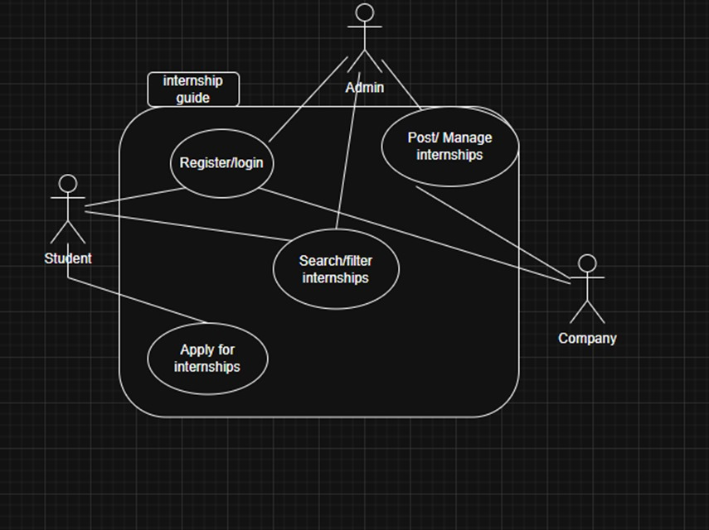

Website Flowchart

Database UML:

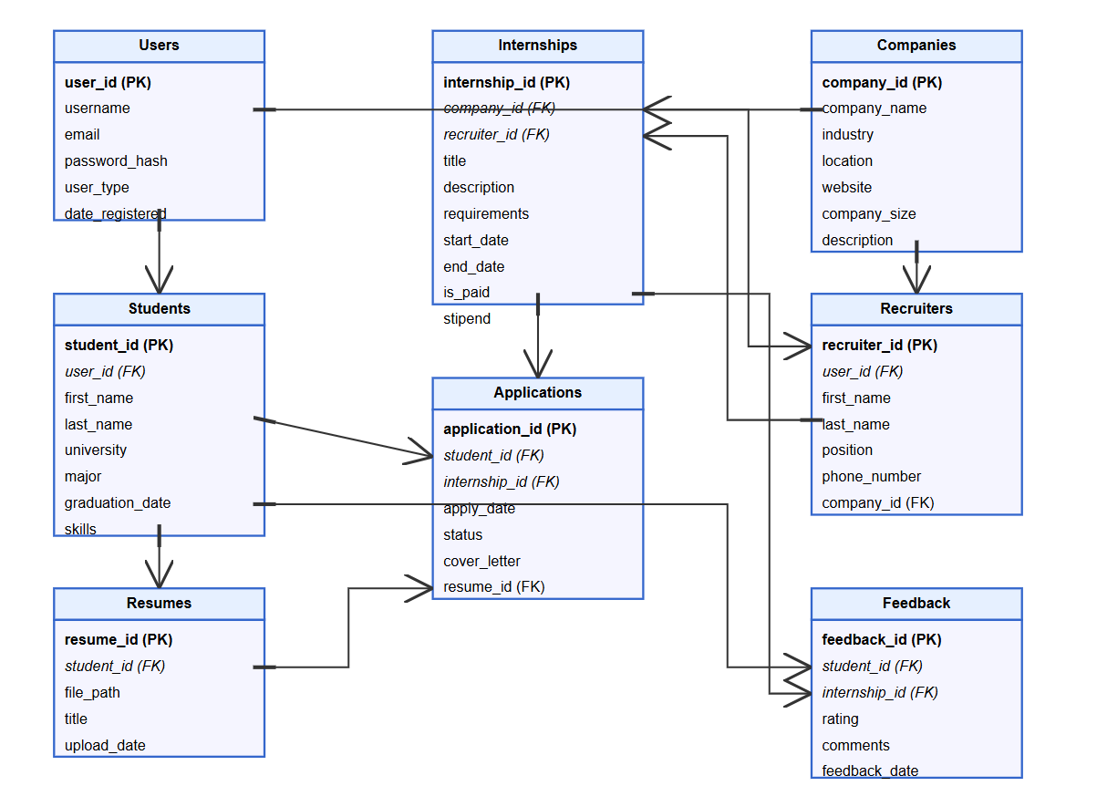

## Dynamic Model

Home Page

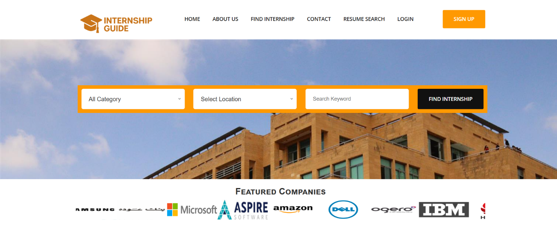

Search Internship   
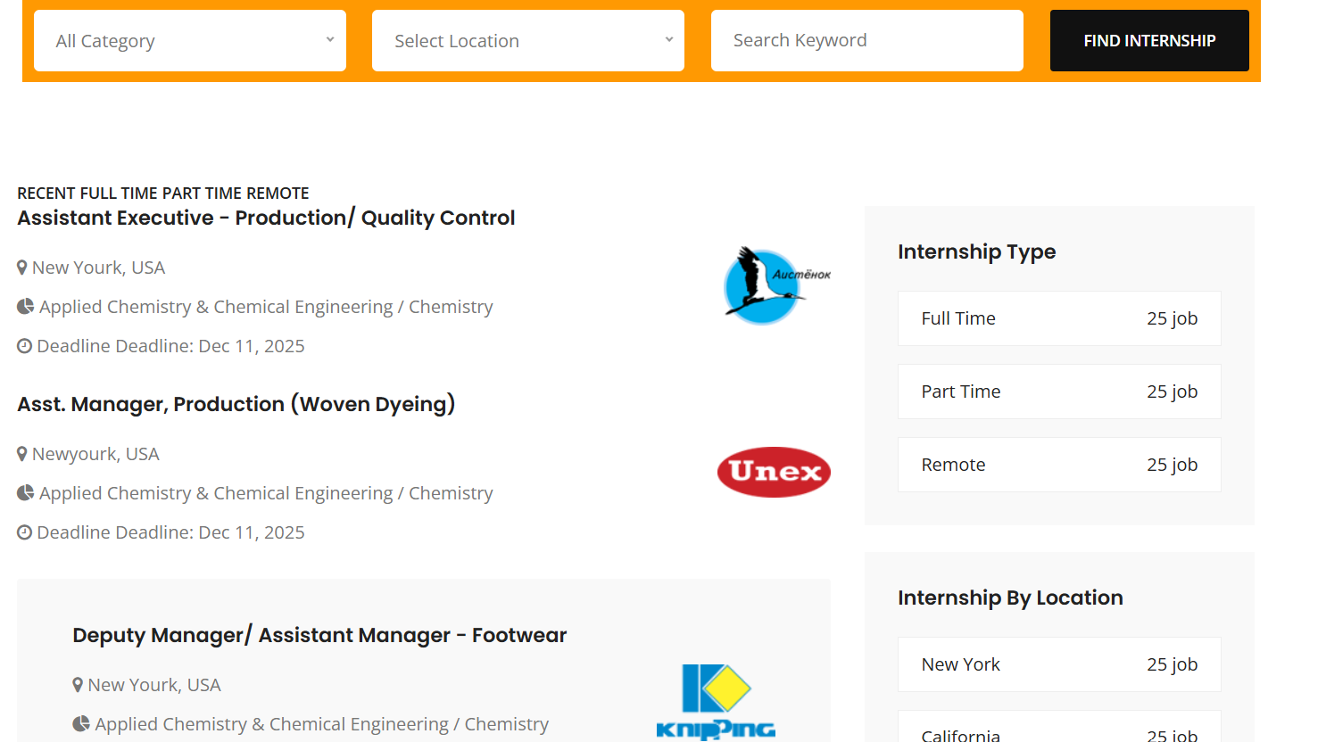

Resume Search

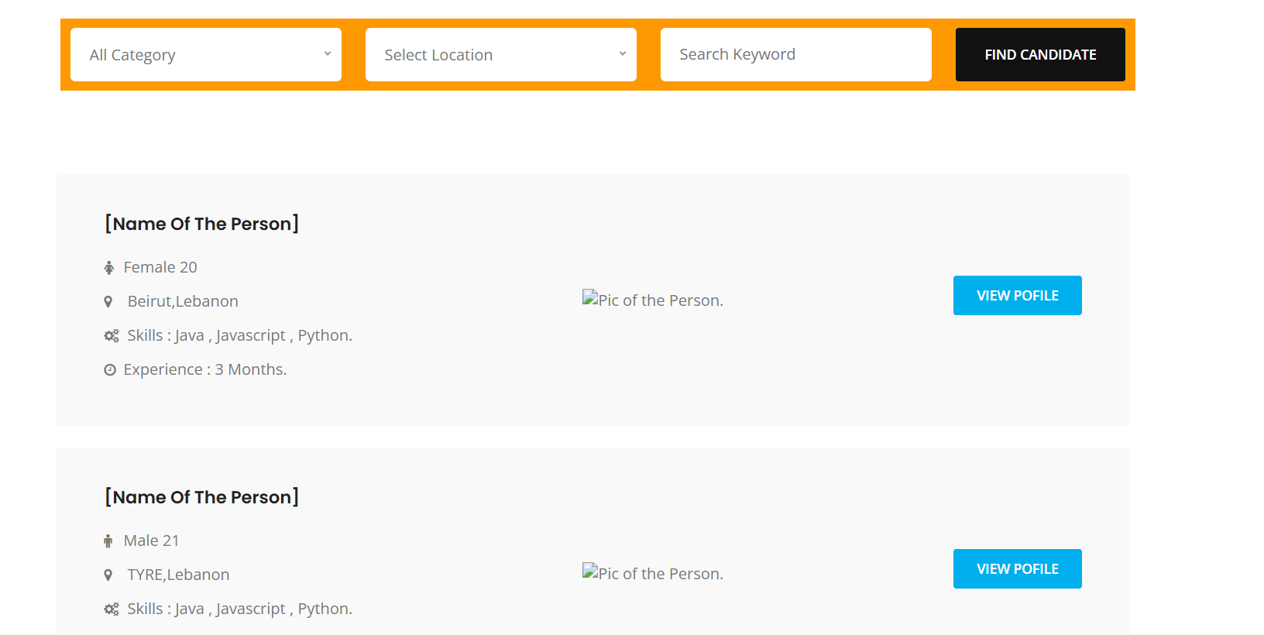

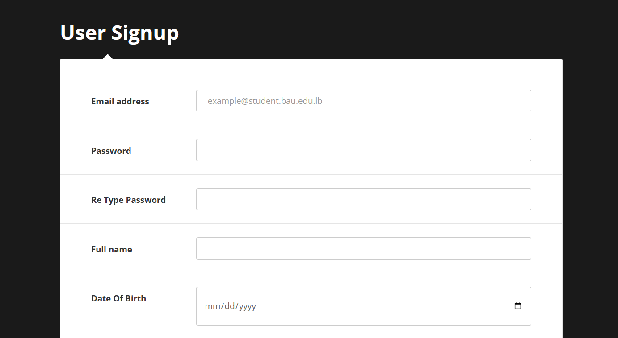

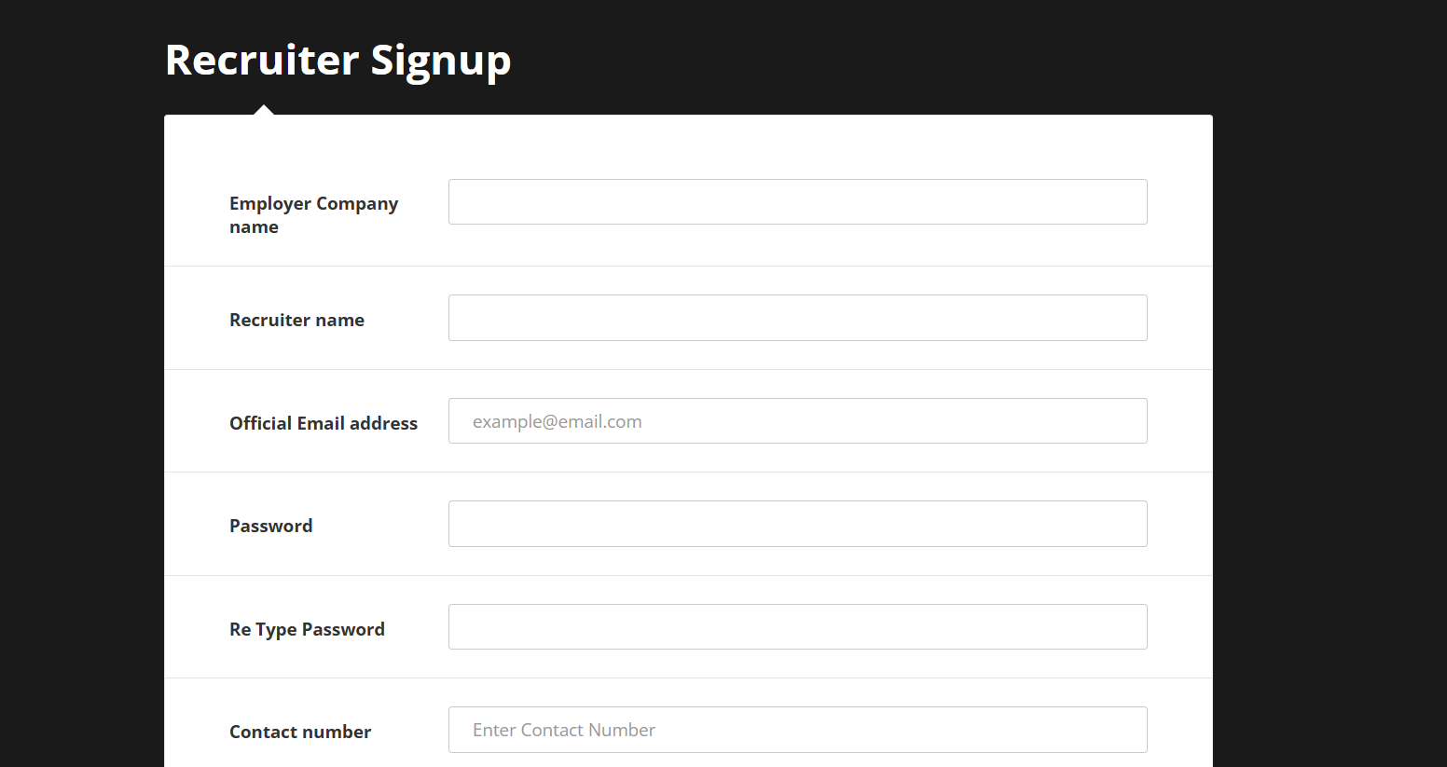

The final version of the website can be accessed through the following link:

<https://omar-omarr.github.io/InternGuide.github.io/>

## Subsystem Decomposition

**Core Subsystems**

From an architectural standpoint, we have divided our internship portal into six primary parts that cooperate while still having distinct roles to play:

* 1. **Authentication Subsystem**
* Manges login, signup, session management, password security.
* It interfaces with the user database to verify credentials.
  1. **Internship Management Subsystem**
* Allow recruiters to publish, edit, and manage internships.
* Handles applications, deadlines, and filtering options.
  1. **Student Management Subsystem:**
* Enables students to make profiles, upload their resumes, and apply to internships.
* It stores education, and experience.
  1. **Search & Recommendation Subsystem**
* It offers keyword-based and filter-based searching.
* It offers recommendation logic based on student profiles and skills.
  1. **Communication Subsystem**
* Facilitates communication between recruiters and students.
* Provides email alerts and system notifications.
  1. **Admin Subsystem**
* Controls system-wide settings and features.
* Oversight of user accounts and permissions.

## Hardware / Software Mapping

|  |  |  |  |  |  |  |  |  |  |  |  |  |  |  |  |  |  |  |  |  |  |  |  |  |
| --- | --- | --- | --- | --- | --- | --- | --- | --- | --- | --- | --- | --- | --- | --- | --- | --- | --- | --- | --- | --- | --- | --- | --- | --- |
| |  |  |  | | --- | --- | --- | | Component | Type | Technology/Hardware Used | | Web Client (User Devices) | Hardware | PC, Tablet, Smartphone with browsers (Chrome, Firefox) | | Frontend | Software | HTML, CSS, JavaScript, Tailwind CSS | | Backend Server | Software | Node.js | | Database Server | Software | MySQL | | Authentication System | Software | Firebase Auth / Node.js with JWT  (not completed) | | Hosting Environment | Hardware | GitHub Pages (Frontend) | | Cloud Storage | Software | Firebase Storage / AWS S3  (not completed) | |

## User Interface

The interface of the platform has been designed to be simple to promote both desktop as well as mobile usage.

**The most important UI elements are:**

* 1. **Home Page:**
* Introducing the platform.
* Gives access to student and recruiter login/signup.
* Highlight opportunities for internships.
  1. **Student Dashboard**
* Allow students to update their profile, upload resumes, and track application statuses.
* Includes smart filtering and search options for finding internships.
  1. **Recruiter Dashboard**
* Allow recruiters to manage their intern postings and review student profiles.
* It offers tools to interact with applicants and monitor applications.
  1. **Search Interfaces**
* Includes resume search and internship filtering tools.
* Crafted with thoughtful dropdowns, tags, and search bars.
  1. **Accessibility and Responsiveness**
* Responsive designs that also have both light and dark modes available.
* Meets WCAG standards of inclusive design

Every screen is designed to enable a smooth experience both by the student and recruiter, providing a contemporary and uniform look across the board.